[Template for weekly studio submission]

Studio {Specify Studio #}

Name and Student Id: {Use multiple names and Ids for group work}

Self-Evaluation {To be highlighted by Student only}:

|  |  |  |  |  |  |
| --- | --- | --- | --- | --- | --- |
| Need Help | Work in Progress | Pass | Credit | **Distinction** | High Distinction |

Tutor Evaluation {To be highlighted by Tutor only}:

|  |  |  |  |  |  |
| --- | --- | --- | --- | --- | --- |
| Incomplete | Needs improvement | Pass | Credit | Distinction | High Distinction |

Task {X.1}:

{Answers}

{Screenshots}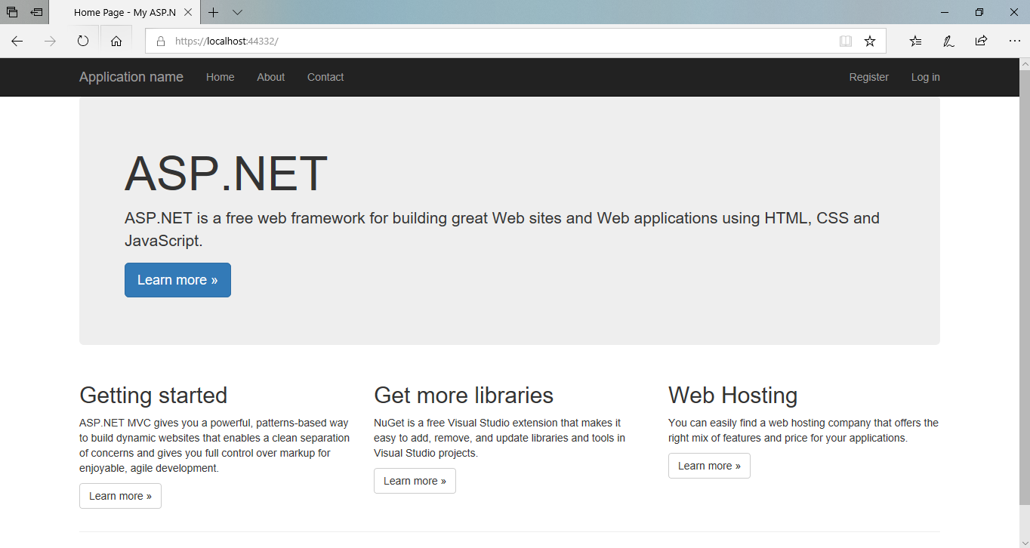

{Link to code repository}

{References}

{URLs}

<https://localhost:44332/>

Task {X.2}:

{Answers}

The five different IDEs I am going to talk about are Visual Studio (VS), NetBeans, PyCharm, IntelliJ IDEA and Eclipse.

Five core features of Visual Studio 2019 Community Edition are “new start window”, “search directly”, “Warnings and recommendations when coding”, “Added search capabilities to the Autos, Locals, and Watch Windows” and “pull request”.

{Screenshots}

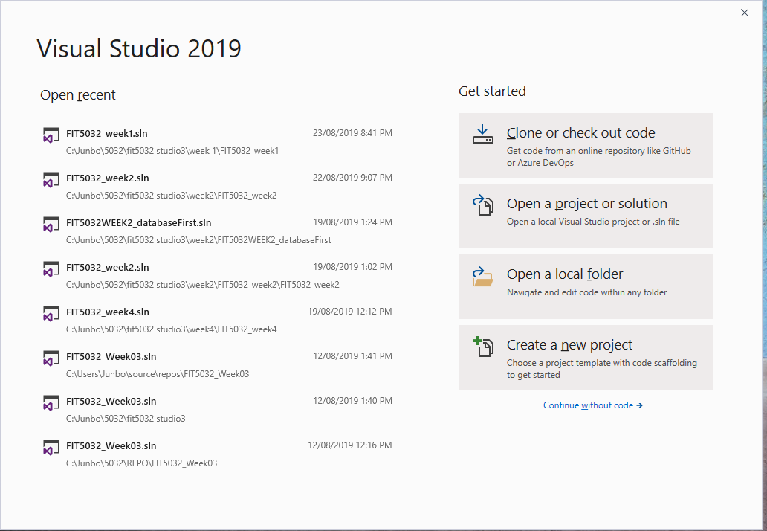

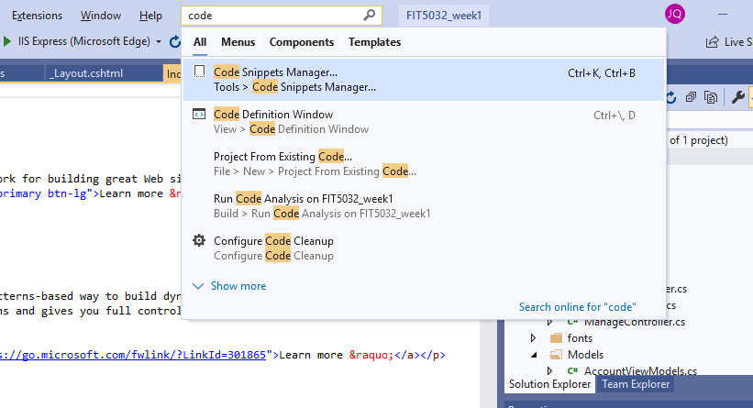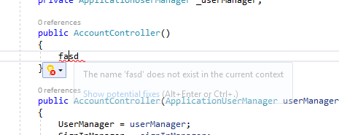

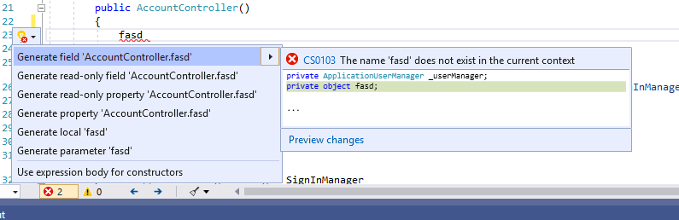

{Link to code repository}

{References}

{URLs}